**Document Type: QA Test Result**

Report Name: **9C_B_04B Purchase Order Summary**

Tester Name: Md. Amin Khan

Test Date: 24-10-2023

**Browser**: Microsoft Edge

**04/12/2023**

**\*\*\*Purchase Order Summary Report is showing Purchase Order Report, Please Add Purchase Order Summary Report**

In UI:

In PDF:

1. Master group wise data is not showing, Data should show master group wise
2. PO Date & Delivery Date format should be dd:mm:yyyy, Sample: 24-10-2023
3. Add more width of Supplier & Supplier BN Column, Supplier BN is not showing
4. Remove Master Group & Master Group BN columns from the grid, because Master group Name will show upper of the grid.

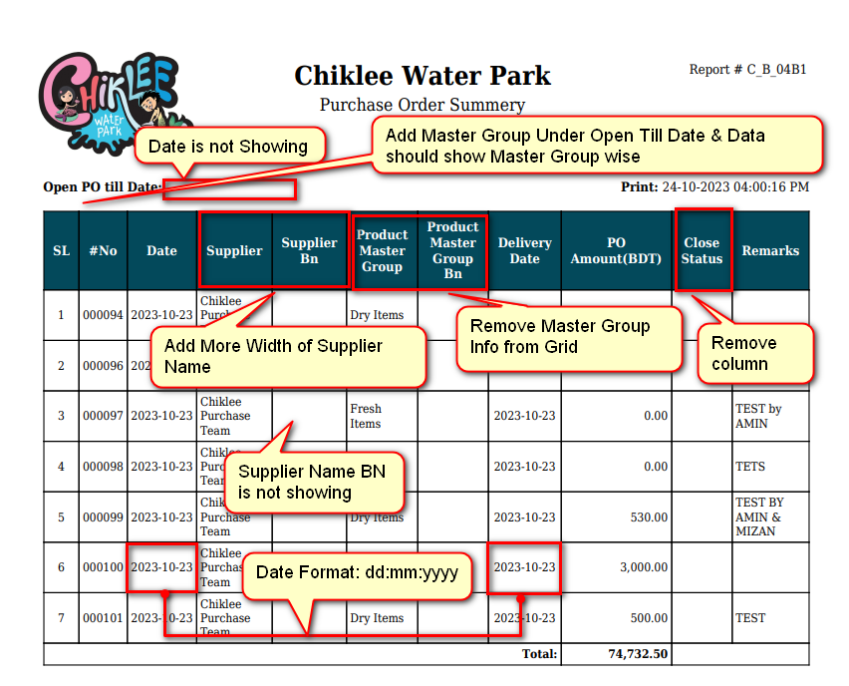

1. Remove Close Status Column from grid, because the report will only show the Open PO Details. Data should show **all PO Number that have Active Status = 1 in PO Master Table.**
2. Optimize PDF Pages 